For this assignment, I decided to work off the data I collected of Bitcoin from my first project as it has all the necessary data that I needed to do an analysis with. Because it had years upon years of currency data collected of it, I could create and plot graphs similar to the ones you see with stock market information. You can also plot graphs differently to look at trends. With my Project 1, I can (and eventually will) collect data on other Cryptocurrency that I find worth mentioning (the others being Etherium and Cardano)

So what has occurred while doing this assignment? I had to reconfigure my data a little because Python didn’t like data being presented a certain way, for example having data that say 08 or the month or day on your data will drive Python bonkers. I also got rid of the special characters for the dollar sign ($) and erroneous commas that were in my data out of my data for easier data manipulation.

One of the most interesting data that I was able to find was imposing the Market Cap line graph with the Volume line graph and found some interesting pointers when the Market Cap goes up, the Volume tends to fluctuate widely as people buy and sell, this is the mark of a healthier stock/cryptocurrency to invest in as a stagnate stock is a bad stock (it means no one wants it, and the people that do have it are just there to hold it.)

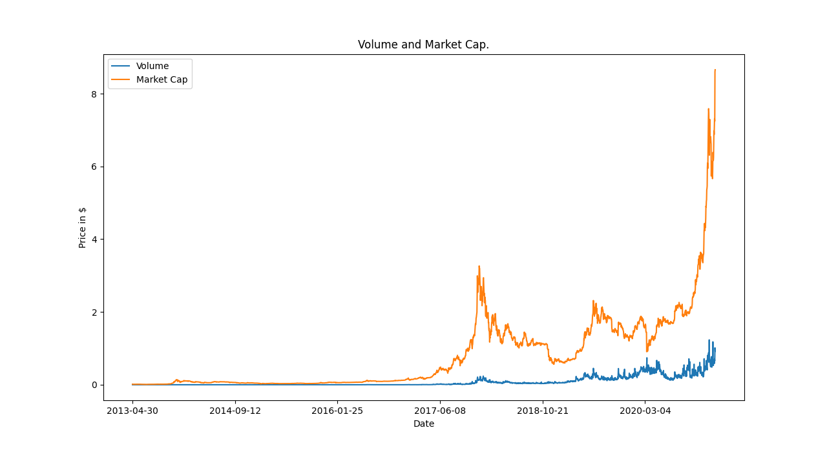Figure: Y-Axis Price is in 100B per increments in 1
When Elon Musk said that he was going to buy 1 Billion worth of bitcoin, that was when the graph fluctuated back and forth widely, during times that didn’t have much news or something as newsworthy as as spending 1 Billion dollars, the buying and selling of Bitcoin tend to stagnate, and at times, decrease in price (until people start buying it back up because of the price dip.)
You can see this occuring similarly during that massive dip in the middle, when it went up (although this picture is too far back) it show increased activity as people sold and bought as it went higher, but stagnated when the price started dropping only to fluctuate again after a year.
While my data is about a week old, it still is pretty accurate when it comes to where Bitcoin is headed. This has been fairly interesting to look at… especially some of the information that I have read on the news. Maybe during this month, we will see some cryptocurrency skyrocket because of news coming from places like Visa.

I did have some issues that needed to be hammered out while getting used to Jupyter but it is a nice way to code and hand out information to others to look at.

